[traciearoseberry@gmail.com](mailto:traciearoseberry@gmail.com) - Nurse Practitioner in Cardiac ICU

Summary of our design:

* A way to split a mechanical ventilator across 2 people that can **individually monitor and adjust** peak inspiratory pressure (**PIP**) and positive-end expiratory pressure (**PEEP**) using **electronically-regulated** pressure valves

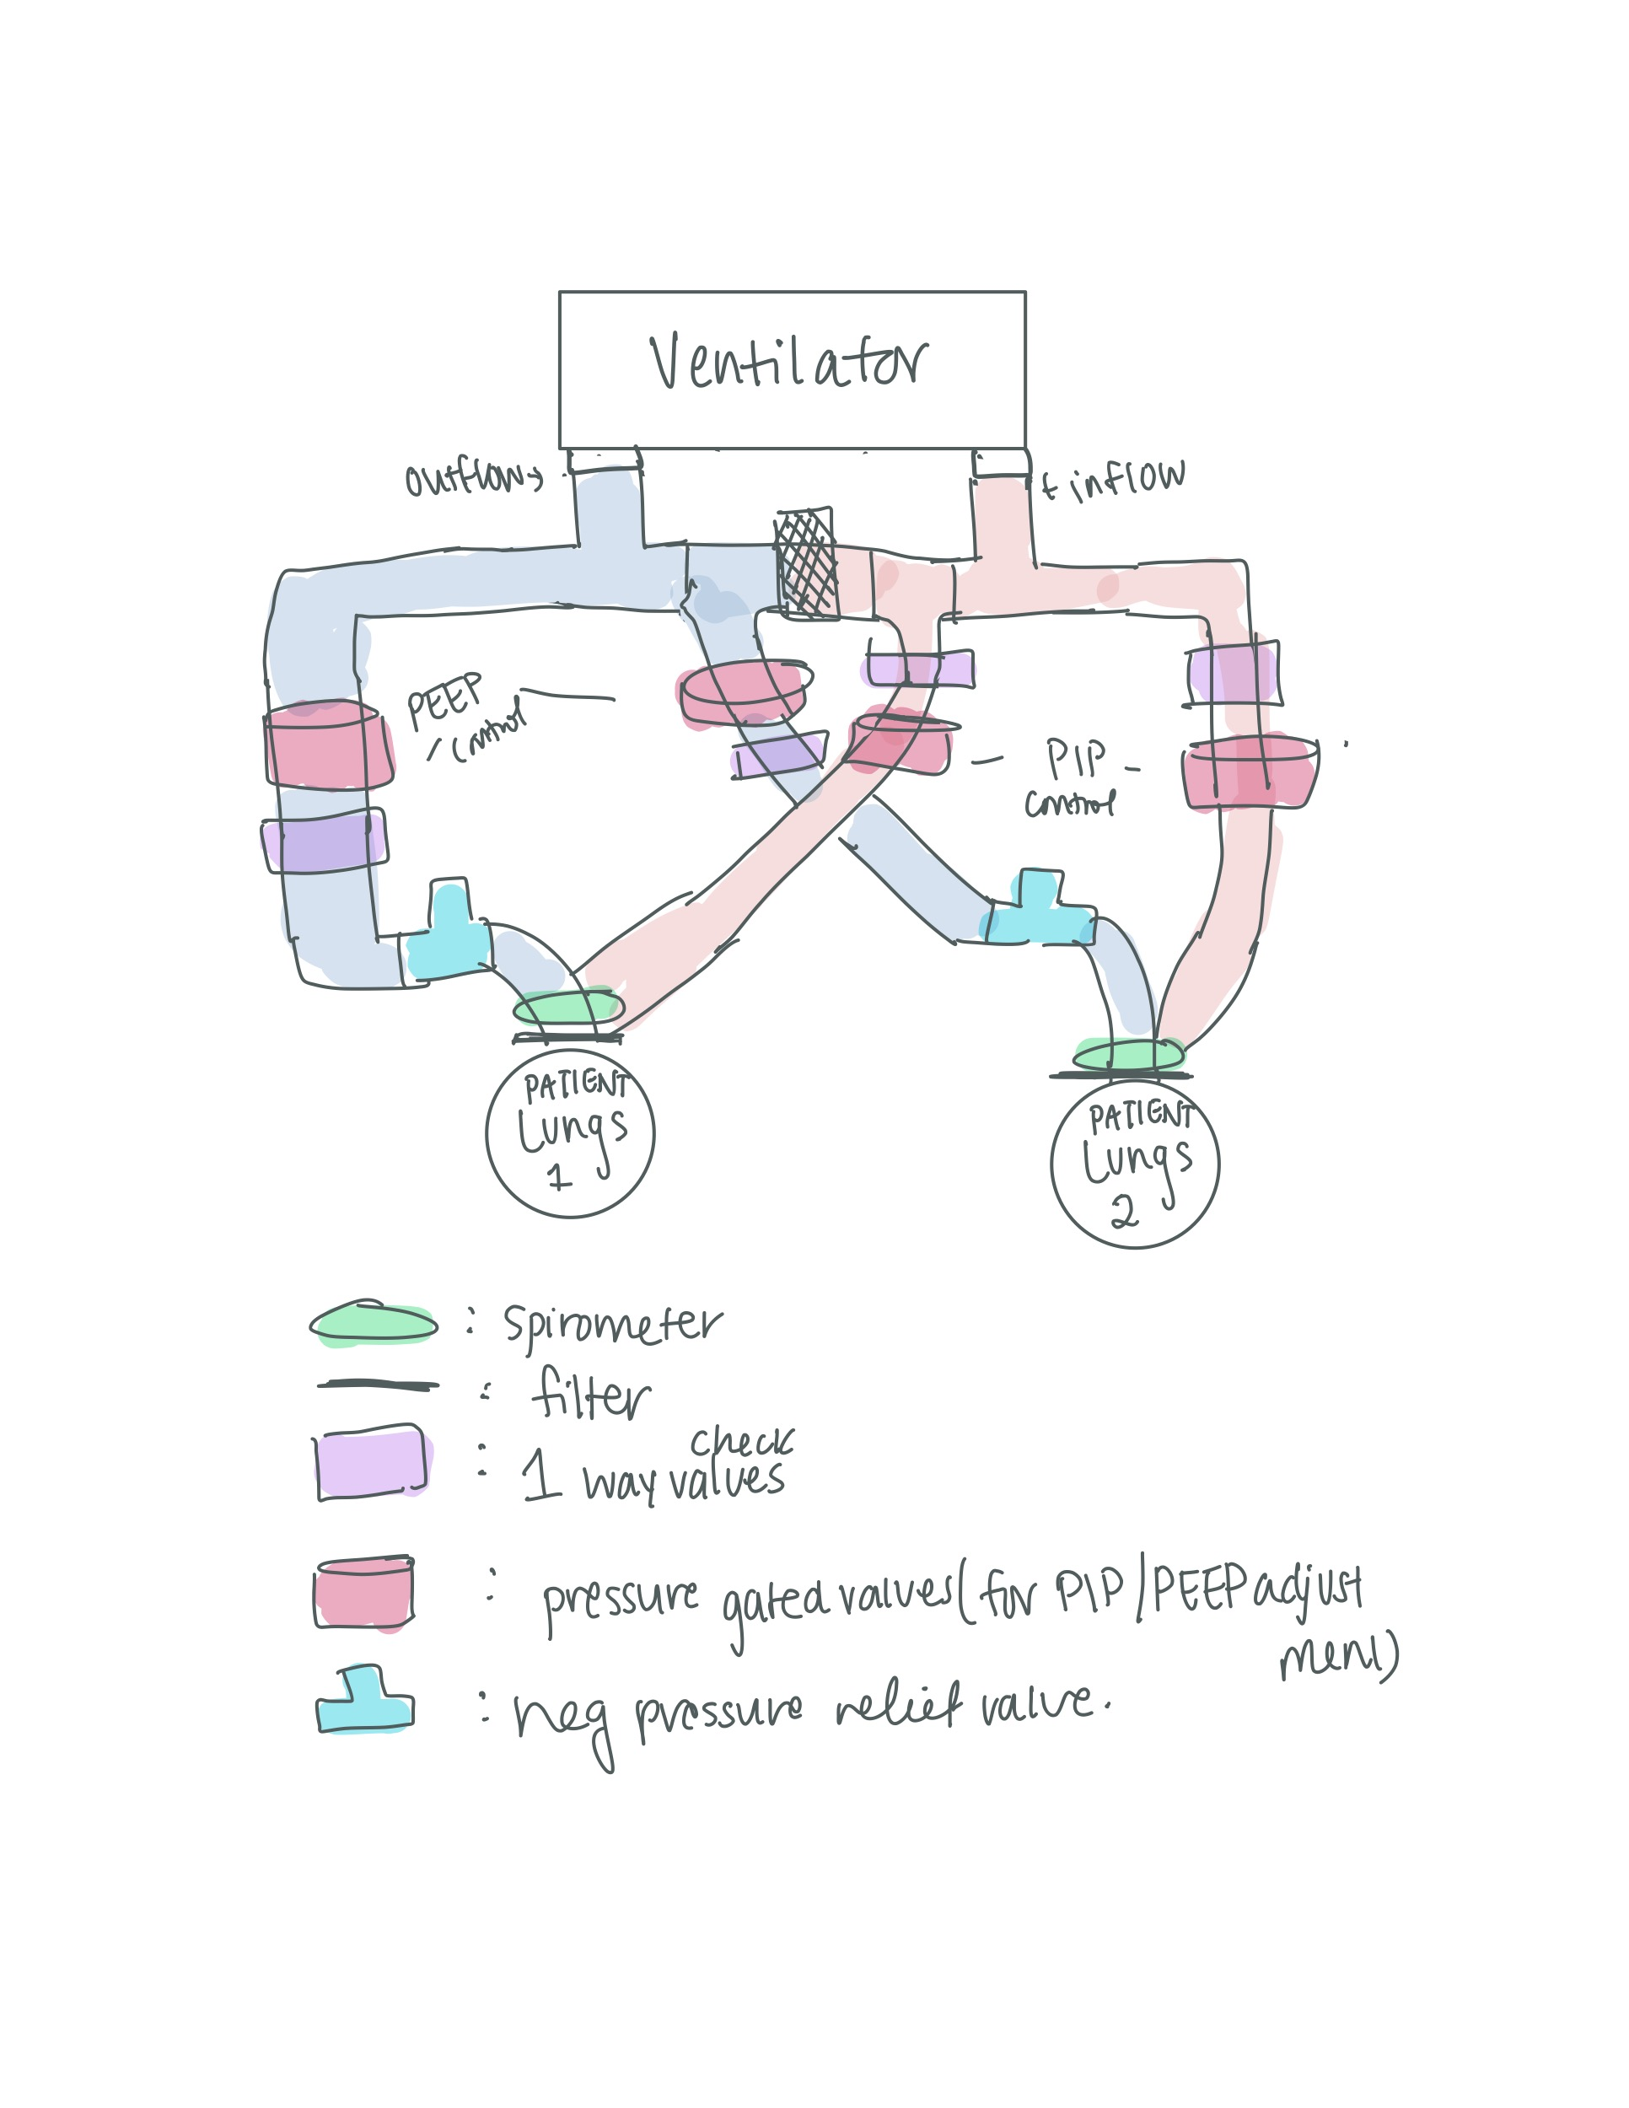

Questions:

1. How does **both tidal volume and inspiratory/expiratory pressure** measurements **play a part in pressure controlled ventilation**?
2. What **alarm**s would be considered **absolutely necessary** for a split ventilator?
   1. Ways the alarm systems can be **improved?**
3. What is the **most common “failure”/warning** on ventilators that you’ve seen?
4. **Opinion on an electronically regulated pressure system?**
   1. **Is it needed?** Concerns about safety/liability/sensitivity + specificity?
   2. How much time would be saved for operators if valves were electronic?
5. Are spirometers absolutely necessary for mechanical ventilators?
6. In patients who may have more variable lung compliance (i.e. Covid-19 patients) **how often** would you say **doctors** have to **change their PIP/PEEP** requirements? Normally is this done by the ventilator itself?